**Description of Course:** This is a 2nd year Spanish course for non-Spanish speakers. Students will study Spanish vocabulary, grammar, both written and orally. The students will learn about the customs and culture of different Spanish speaking countries. Students will do presentations in Spanish.

**Distance Learning Expectations:**

* **Students will check teacher webpage daily**
* **Students will follow academic honesty and not engage in plagiarism or cheating**
* **Students will complete all assignments and submit them on time**

**Grade Policy**

A= 100%-90%

B= 89%-80%

C= 79%-70%

D= 69%-60%

F= 59% and lower

**Weighted Grades:**

Test/Quiz/Final- 60%

Assigned work- 20%

Participation (journals/oral presentations)- 20%

**When will Assignments/Assessments Be Assigned?**

Assignments will be given Monday-Thursday and are due by 11:59 pm on Friday. Students will turn in completed assignments at the due time. Late work is not accepted. Quizzes and Chapter Tests will be given on Friday’s and must be taken on that day.

**How to Find and Submit Assignments/Assessments**

We will be using Google Classroom, FlipGrid and Illuminate online. These are accessible through student’s ClassLink. Add them by clicking the + sign (green) to add the app to your ClassLink.

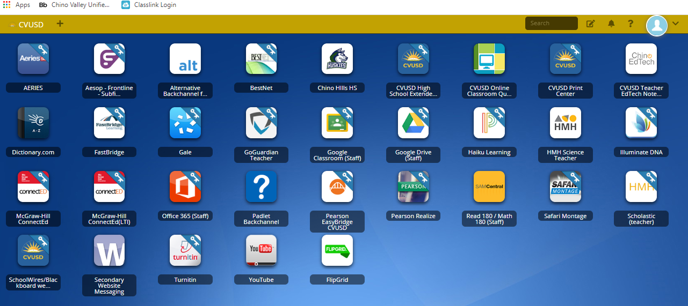

**Office Hours:**

**Monday and Wednesday 11:00-1:00 pm via Email**

**2nd Semester**

* Chapter 3B – ¿Como se va …? - How do you get to …?
* Objectives: Give directions for getting to places. Give some friend directions for a task. Discuss driving and safe driving habits. Express possessions. Understand cultural perspectives on neighborhoods.
* Chapter 4A – Cuando éramos niños - When we were children.
* Objectives: Describe childhood toys and things. Describe what you were like as a child. Talk about activities that you did as a child. Describe to whom or for whom something is done for. Understand cultural perspectives on childhood songs.
* Chapter 4B – Celebrando los días festivos. – Celebrating special occasions
* Objectives: Describe holiday celebration. Talk about your family and celebrations. Describe people , places and situations in the past. Talk about how people interact. Understand cultural perspectives on holidays and special events.
* Chapter 5A – Un acto heroico – A heroic act.
* Objectives: Discuss emergencies, crises, rescues and heroic acts. Describe past situations and settings. Describe weather conditions. Understand cultural perspectives on natural disasters and legends
* Chapter 5B – Un accidente. – An accident
* Objectives: Describe an accident scene. Talk about injuries and treatments. Talk about what you were doing when and accident occurred. Understand cultural perspectives on health.
* Chapter 6A – ¿Viste el partido en la televisión? – Did you see the game on TV?
* Objectives: Talk about what you saw on TV. Describe how you feel about watching TV. Talk about how people interact. Understand cultural perspectives on TV programs in Spanish speaking countries.
* Chapter 6B – ¿Que película has visto? – What movie have you seen?
* Objectives: Discuss movie plots and characters. Give opinions on movies. Talk about activities you have done. Understand cultural perspectives on movies
* Chapter 7A – ¿Como se hace la paella? – How do you make paella?
* Objectives: Talk about food and cooking. Tell others what not to do. Describe what people generally do. Understand cultural perspectives on recipes and food preparation.
* Chapter 7B – ¿Te gusta comer al aire libre? – Do you like to eat outdoors?
* Objectives: Discuss food and outdoor cooking. Tell people what to do or not do. Indicate duration, exchange, reason, and other expectations. Understand cultural perspectives on special foods and outdoor food vendors.